BUAN/OPRE 6398.003 Prescriptive Analytics

Homework 3

Team 6

Taeho Kim
Lin Li
Madhuri Kashyap
Manasa Venkatesh
Thomas Trieu
Yu-Min Wang

2.
Cj | 5 2 0 0 M |
------------------------------------------
VIS | x y u v w | SQ
------------------------------------------
0 u | 3 6 1 0 0 | 45 45/3 = 15
M w| 1 0 0 -1 1 | 9 9/1 = 9
------------------------------------------
Zj | M 0 0 -M M | 9M
Zj - Cj | M-5 -2 0 -M 0 |

Cj | 5 2 0 0 M |
------------------------------------------
VIS | x y u v w | SQ
------------------------------------------
0 u | 0 6 1 3 -3 | 18
5 x | 1 0 0 -1 1 | 9
--------------------------------------------
Zj | 5 0 0 -5 5 | 45
Zj – Cj | 0 -2 0 -5 5-M|

The current solution is optimal since all numbers in Zj-Cj are negative or 0. The optimal solution (x*, y*) = (9, 0) and the optimal objective function value is Z* = 45.

3.
Objective Cell (Max)
 | Cell | Name | Original Value | Final Value
 | $B$8 | Z | 9380 | 9380
Variable Cells
 | Cell | Name | Original Value | Final Value | Integer
 | $C$8 | x | 32 | 32 | Contin
 | $D$8 | y | 14 | 14 | Contin
Constraints
 | Cell | Name | Cell Value | Formula | Status | Slack
 | $E$10 | LHS | 300 | $E$10<=$G$10 | Binding | 0
 | $E$11 | LHS | 22 | $E$11<=$G$11 | Binding | 0

The optimal solution is (x*, y*) = (32, 14) and the optimal objective function value is Z*=9380. In other words, they should carry 32 coconuts and 14 lion skins on the boat to maximize the wealth which is 9380.

4.
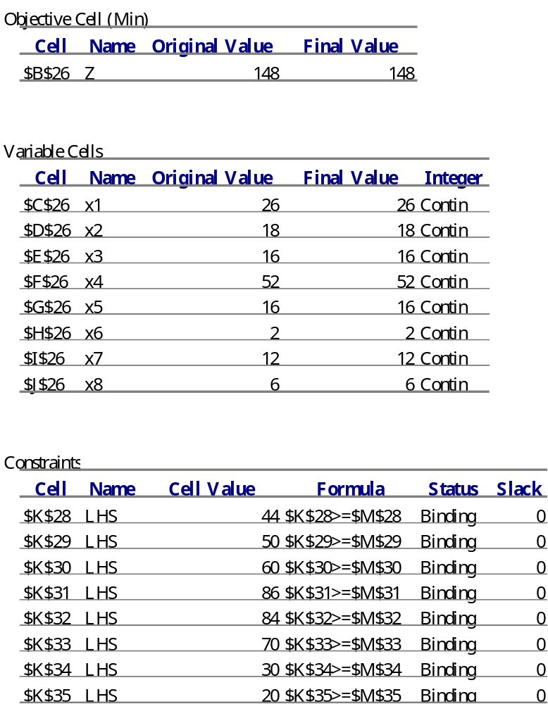

The optimal solution is (x1*,x2*,x3*,x4*,x5*,x6*,x7*,x8*) = (26,18,16,52,16,2,12,6) and the optimal objective function value is Z*=148. There should be 26 nurses starting to work at 6AM, 18 nurses starting to work at 9AM, 16 nurses starting to work at 12PM, 52 nurses starting to work at 3PM, 16 nurses starting to work at 6PM, 2 nurses starting to work at 9PM, 12 nurses starting to work at 12AM, 6 nurses starting to work at 3AM. The minimum number of nurses to meet the requirements is 148.

